Content diagram

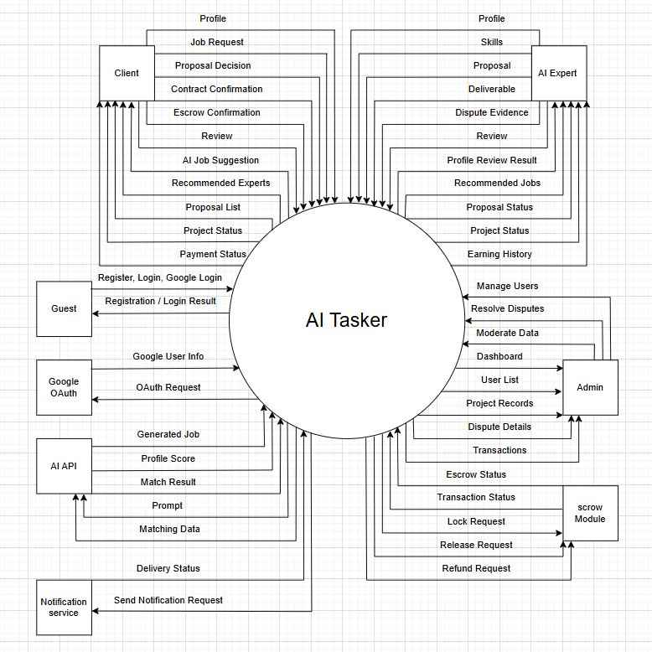

Main Flow

Flow 1: Register/Login with Email or Google & Role-based Profile Verification
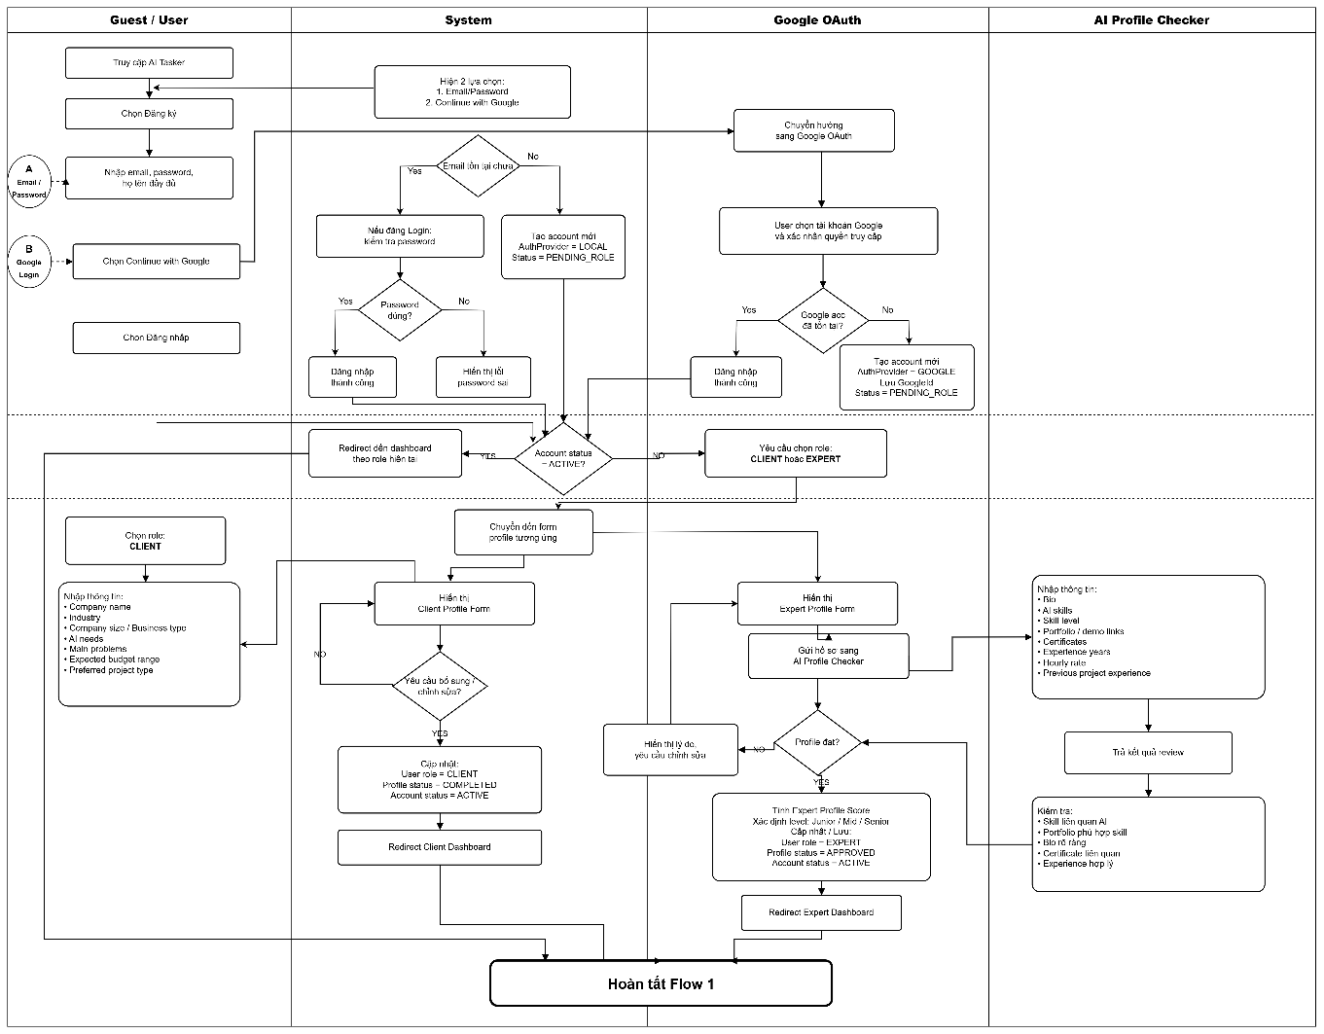

Flow 2: Client Creates Main Request / Job with AI Job Assistant
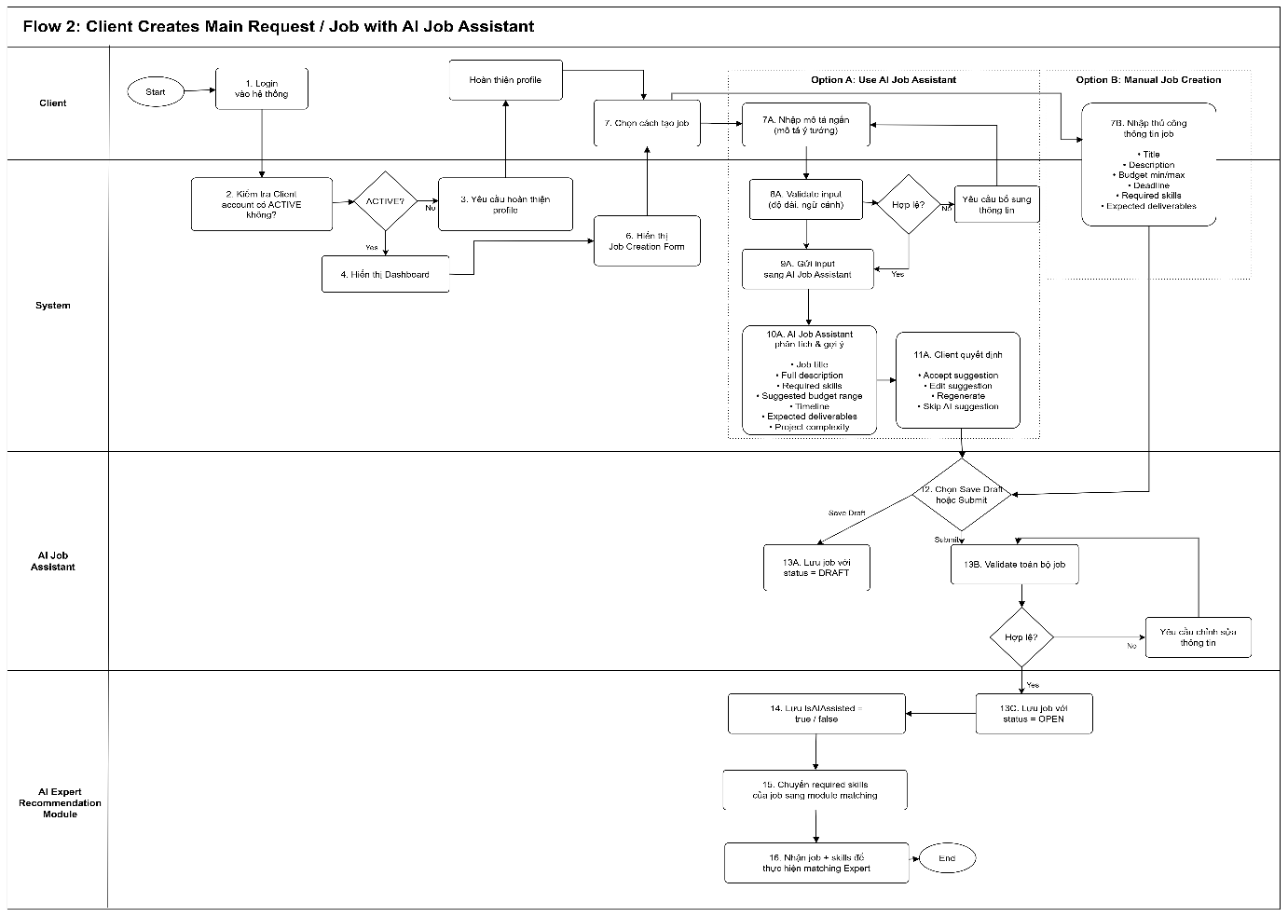

Flow 3: System Matches Client Main Request with AI Expert Skills
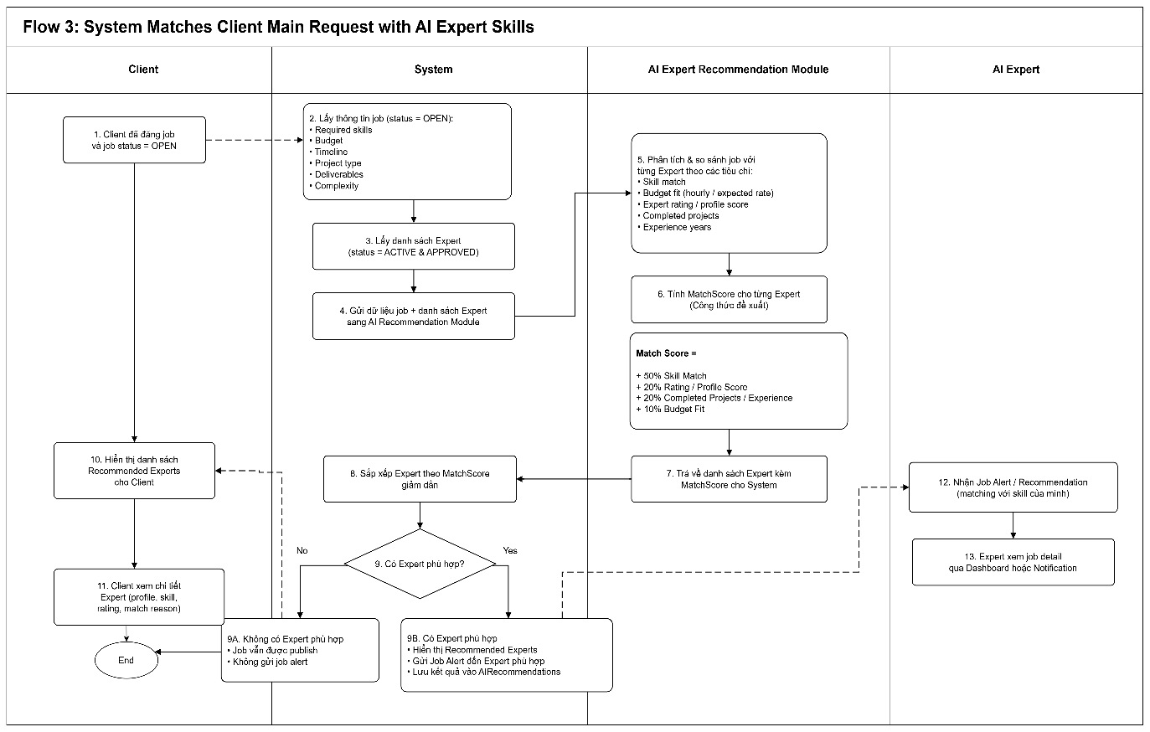Flow 4: Expert reviews AI-recommended jobs / browses jobs and sends proposals
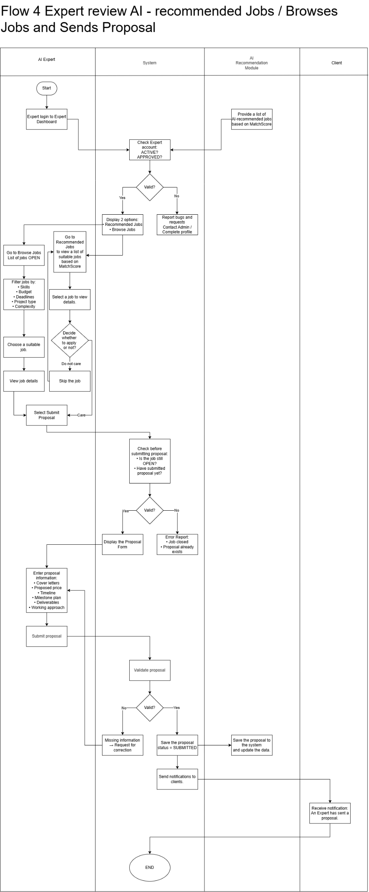

Flow 5: Client and Expert Negotiate and Confirm Project Terms
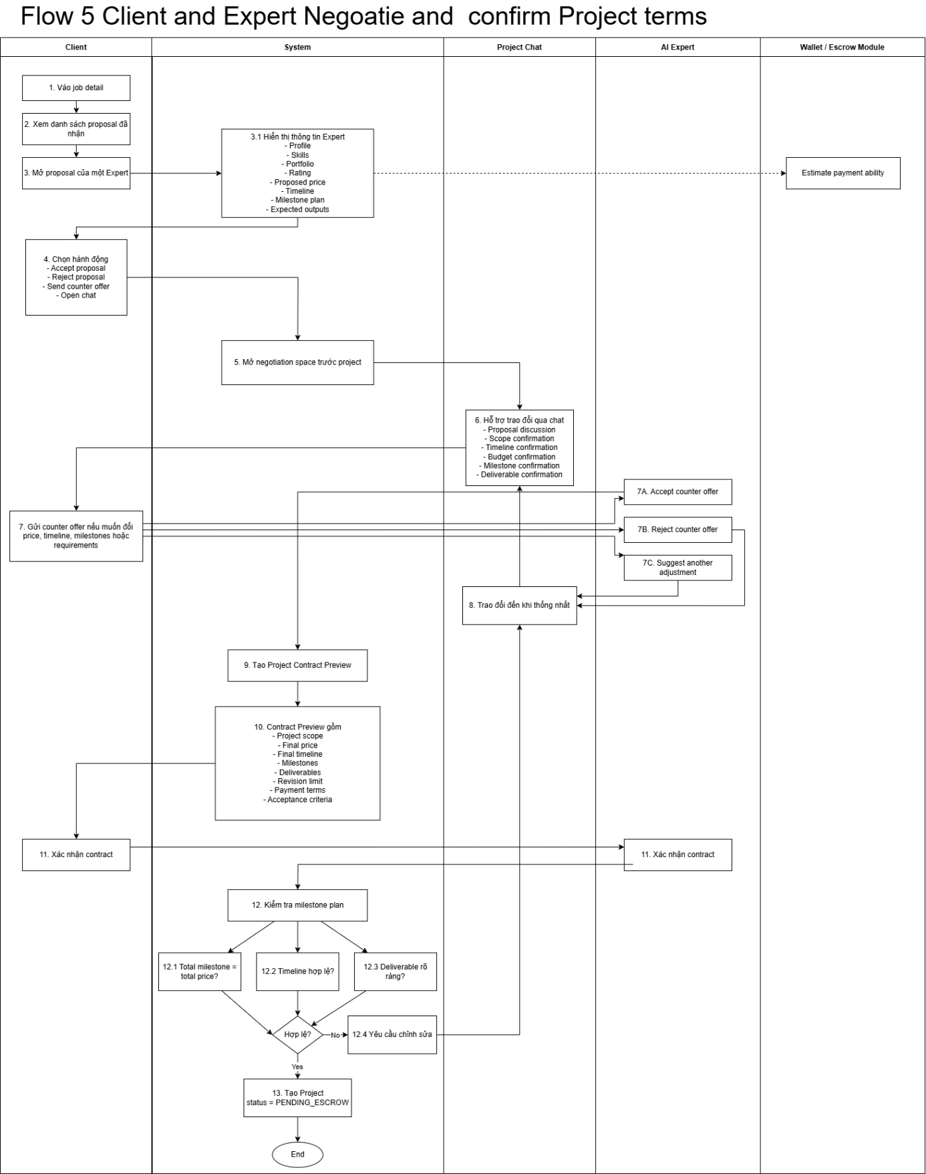

Flow 6: Wallet-based Escrow Management and Project Execution
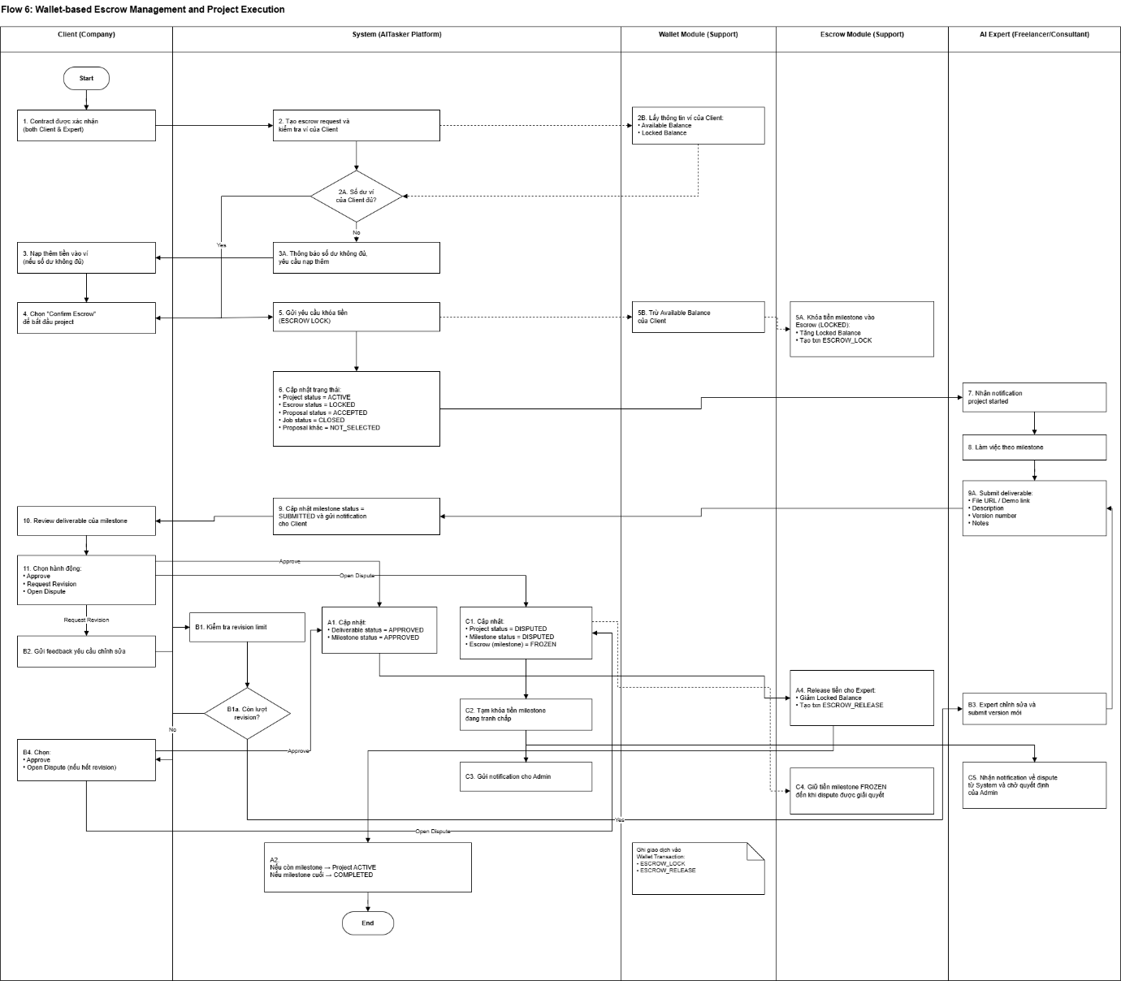

Flow 7: Dispute Resolution, Project Completion, Review and Rating
